# Data Science & Analytics: Project 1 - Proposal

## Project proposal submitted by: The Confabulators

* Andrew Boring
* Michael Coates
* Jin Kim
* Karen Mosley
* Srini Mudivarthy

### Hypothesis:

Increased coffee consumption within a population correlates with increased productivity, as measured in GDP per capita.

Null Hypothesis:

There is no correlation between coffee consumption and success as measured above.

### **Abstract**:

On an individual level, consumption of coffee and its active ingredient, caffeine (a stimulant), is associated with higher levels of “energy” and “productivity”. In a given population, such as a nation-state, does increased coffee consumption in the larger population itself indicate a higher level of productivity?

### Approach:

In this analysis, we will use the data from the International Coffee Organization on coffee consumption for a select list of industrialized nations from 1990 through 2017 and compare it to GDP data from for the same time period.

**Preliminary Questions:**

* What is the mean GDP (combined) for the selected nations over the time period?
* What is the mean coffee consumption (combined) for the selected nations over the time period?
* What is the mean GDP for individual nations over the time period?
* What is the mean coffee consumption for individual nations over the time period?
* Is there a correlation with other indicators of productivity or success, such as the unemployment?
* Is there a "rate of increase" that we can correlate?

In order to determine if the hypothesis is met or not, we will also need to establish which populations did not experience similar increases in GDP output.

### **D**ata:

We have two primary data files, coffee consumption and GDP.

[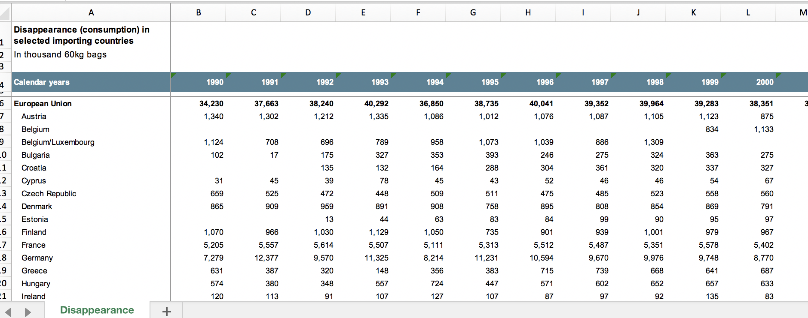](https://github.com/mosleykc/Confabulators_Project_1/blob/master/images/coffee_data.png)

Figure 1: Coffee Consumption

[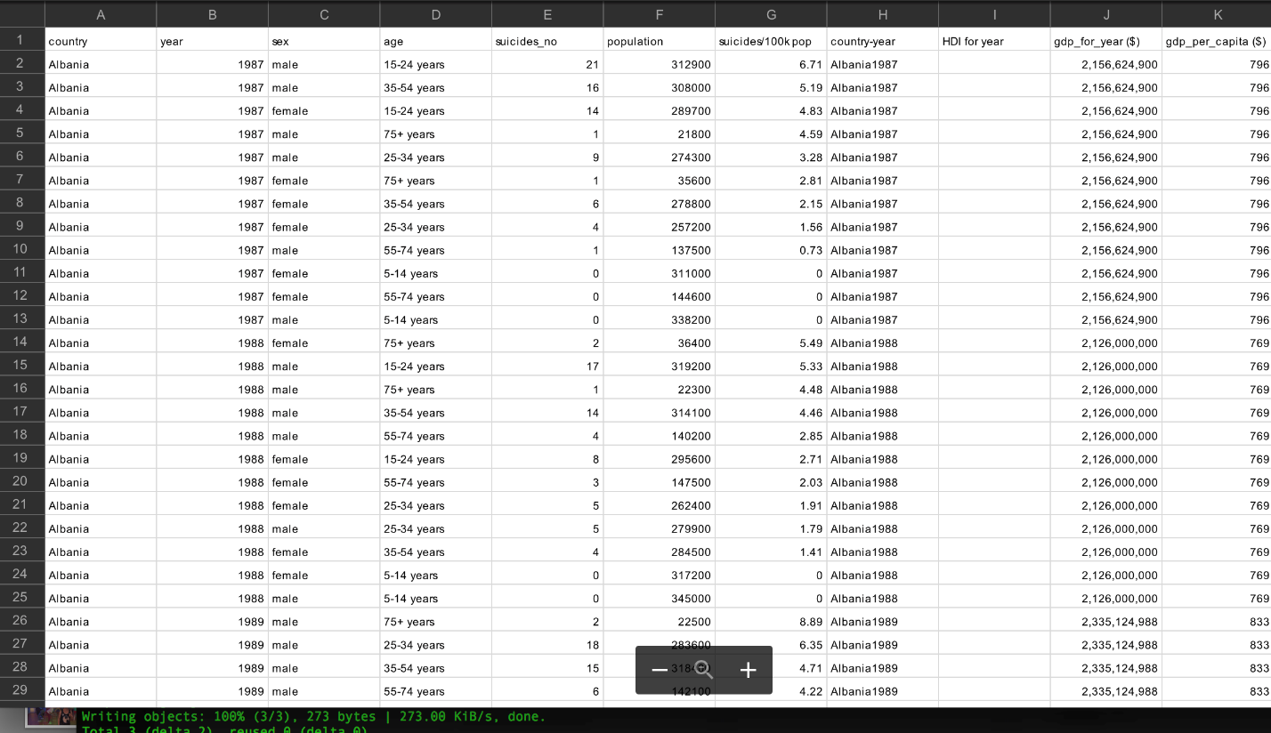](https://github.com/mosleykc/Confabulators_Project_1/blob/master/images/gdp-data.png)

Figure 2: GDP Data

Additional data files include Unemployment and an ISO Country Code to Country Name mapping.

### Data Sources:

* International Coffee Organization: <http://www.ico.org/new_historical.asp>

### Limitations:

* The ICO coffee consumption data is measured in terms of "disappearance". Disappearance is measured by adding gross imports, production, and existing inventories, and subtracting exports and other non-consumptive use. The resulting "disappearance" is used as a proxy for consumption
* The disappearance data consists of western, industrialized nations within the European Union, United States, and select others such as Tunisia, Russian Federation, Japan, and Norway. The Data lacks information on nations within Asian or African geographic regions, and no developing nations.
* Disappearance data for most countries ends at 2014, though several continue through to 2017.
* GDP data was expressed in multiple currencies. Since we are looking for trends and correlations between GDP and consumption, and not specific dollar amounts, we ignored currency and currency calculations. Instead, we used the GDP value for each country as-is.